Unit 1 Grade 10 Applied
Similar Triangles

Lesson Outline

BIG PICTURE

Students will:
- investigate similar triangles using their prior knowledge of ratio and proportion;
- solve problems related to similarity, including those using imperial and metric measures;
- manipulate and solve algebraic equations, using prior skills and building new skills to solve equations involving fractions as needed to solve problems;
Day | Lesson Title | Math Learning Goals | Expectations
1 | Introduction | - Introduction to course  - Concept of proportions | MT 1.01  CGE 5e
2 | Metric Systems | - Activate prior knowledge on converting metric measurements  - Introduce concept of similarity | MT1.01, LR1.01  CGE 3b, 4b, 5e
3 | Similar Triangles: Perimeter and Area Relationship | - Investigate the relationship between the perimeter and the area of similar triangles  - Use the Pythagorean relationship to find information about triangles | MT1.01, MT2.02  CGE 2c, 3c
4 | What Is Similarity? | - Investigate the properties of similar triangles using geoboards, e.g., corresponding angles are equal and corresponding sides are proportional | MT1.01  CGE 3b, 5a
5 | Properties of Similar Triangles | - Investigate the properties of similar triangles, i.e., corresponding angles are equal and corresponding sides are proportional, using concrete materials | MT1.01, MT1.02  CGE 3c, 4b
6 | Solving Those Proportions | - Identify and create proportional ratios  - Solve proportions to obtain missing information in similar triangles | LR1.01, MT1.02, MT 1.03  CGE 4b, 5b
7 | How Far? How High? | - Solve problems involving similar triangles using primary source measurement data | MT1.02, MT1.03  CGE 4b, 5a, 5c
8 | Proportions Potpourri | - Consolidate concept understanding and procedural fluency for proportions and similar triangles  - Solve problems involving ratios, proportions and similar triangles in a variety of contexts | LR1.01, MT1.03  CGE 5a, 5b
9 | Assessment | - A summative performance task for units 1 and 2 is available from the members only section of the OAME web site www.oame.on.ca
10 | Jazz Day

Unit 1: Day 1: Introduction |  |  |  |  | Grade 10 Applied
Minds On: 30 Min. |  |  | Math Learning Goals  - Introduction to course  - Concept of proportions  - Activating problem solving skills.  - Activate cooperative learning skills. |  | Materials  - BLM 1.1.1, 1.1.2, 1.1.3
Action: 25 Min. |  |  |  |  | Materials  - BLM 1.1.1, 1.1.2, 1.1.3
Consolidate/  Debrief: 20 Min |  |  |  |  | Materials  - BLM 1.1.1, 1.1.2, 1.1.3
Total = 75 Min. |  |  |  |  | Materials  - BLM 1.1.1, 1.1.2, 1.1.3
Assessment
Opportunities
 | Minds On… | Whole Class à Guided Discussion  Conduct ice-breaker activity.  Do survey BLM 1.1.1 |  |  | Sample survey is provided but should be modified based on community and personal preferences.  Problem solving scenarios are suggestions and may be supplemented or changed.  See introductory materials for cooperative learning strategies and the importance of establishing group roles and social skills before starting cooperative learning tasks.
 | Action! | Groups of 2 à Problem Solving  Students work on two problems: Tug of War and Fruit Square BLM 1.1.2  Mathematical Processes/Problem Solving/Checklist: Assess how students state a hypothesis, apply problem-solving strategies, and adjust their hypothesis based on new information.
 | Consolidate Debrief | Whole Class à Guided Discussion  - Take up solutions  - Have students write solutions on chart paper or board or mini white boards.  - Have groups present their solutions.  - Teacher should ensure that they tease out the important mathematics as the students present their solutions. Also ensure that students who have solved using a similar solution are involved in the process.
Application |  | Home Activity or Further Classroom Consolidation  Complete Dog Food Question 1.1.3

It’s All About Me

The last math course that I took was __________________

The mark I received in that course was __________.

The things I like most about math are __________________________________ ________________________________________________________________________________________________________________________________

The things I don’t enjoy about math are ________________________________
________________________________________________________________________________________________________________________________

I am taking this course because ______________________________________
________________________________________________________________

I hope to achieve a mark of ______ %. I am going to achieve this mark by doing the following:
________________________________________________________________________________________________________________________________

After school, I’m involved in (fill in the chart):
Activity | Description | Time per week
Job
Sport/Club
Other

I would prefer to sit _________________________ because ________________
________________________________________________________________

If you need to call home, you should speak to ___________________ who is my _________________ because _______________________________________
________________________________________________________________

You should know that I have (allergies, epilepsy, diabetes,…) _______________
________________________________________________________________

Some other things you should know about me ___________________________
________________________________________________________________
________________________________________________________________

In 10 years I hope to _______________________________________________
________________________________________________________________

1.1.2 What’s on the Menu?

Teachers vs. Students
(Adapted from About Teaching Mathematics by Marilyn Burns, Math Solutions Publications, 2000)

Who will win the tug of war in round 3?

VS

Round 1: On one side are four teachers, each of equal strength. On the other side are five students, each of equal strength. The result is dead even.

Round 2: On one side is Buddy, a dog. Buddy is put up against two of the students and one teacher. The result, once again is dead even.

Round 3: Buddy and three of the students are on one side and the four teachers are on the other side.

Who do you think will win the third round? Explain.

Puzzling Fruit

In the puzzle below, the numbers alongside each column and row are the total of the values of the symbols within each column and row. What should replace the question mark? Make sure you provide a full and detailed solution.
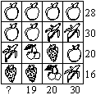

1.1.3 What’s on the Menu?

Buddy's Hungry!

Buddy, one of the teacher's dogs, is very hungry. Ms. Jones stops at the pet store on her way home from school. She is always looking for the most economical buy. While at the pet store, she notices the following prices of pet food:
BUDDY
Five 150 mL cans of Perfect Pet dog food for $1.26
Twelve 400 mL cans of Doggies Love It for $7.38
Ten 150 mL cans of Rover's Chow for $2.60
Six 400 mL cans of Man's Best Friend for $3.94

Which pet food should Ms. Jones buy? Explain in as many different ways as possible.

Unit 1 Day 2 : Metric Systems |  |  |  |  | Grade 10 Applied
Minds On: 25 Min. |  |  | Math Learning Goals  - Converting metric measurements  - Introduce concept of similarity |  | Materials  - BLM 1.2.1, 1.2.2, 1.2.3, 1.2.4  - Rulers  - Construction paper
Action: 20 Min.
Consolidate/
Debrief: 30 Min
Total = 75 Min.
Assessment
Opportunities
 | Minds On… | Whole Class → Find Your Partner  Have students match their card with someone in class.  Students will be given a measurement and they have to find someone in class with the same measurement but different unit (BLM 1.2.1.)  Whole Class → Discussion  Review metric conversion methods with whole class (BLM 1.2.2). |  |  | Text box at start of BLM 1.2.2 is left blank for inclusion of own graphic organizer to explain metric conversions.  Assess teamwork learning skills.  Review cooperative learning skills.  Refer to sample checklist from lesson 1.  Encourage one pair to share, then next pair is to add what is new or unique, and so on until all have shared.  Assess initiative learning skill.
 | Action! | Pairs → Metric Review  Students use metric conversions to prepare a chart that has a complete set of metric prefixes for their pair of measurements in order from greatest to least. For example, 0.001 kilometre, 0.01 hectometre, 0.1 dekametre, 1 metre. Metric charts will be posted on the wall to create a reference for students.  Students work in pairs to complete the metric review sheet BLM 1.2.2.  Mathematical Processes/Problem Solving/Checklist: Assess how students state a hypothesis, apply problem-solving strategies, and adjust their hypothesis based on new information.
 | Consolidate Debrief | Whole Class → Guided Discussion  - Take up solutions to BLM 1.2.2.  - Have student write solutions on paper, mini-white boards or board  - Have pairs present their solutions  Suggest quick methods of conversion
Application  Concept Practice  Skill Drill |  | Home Activity or Further Classroom Consolidation  Complete BLM 1.2.3.  Complete BLM 1.2.4 on Similarity. |  |  | Assess work habits learning skill.

1.2.1: Matching Metric Measurements - Teacher

Investigation
Find a student in your class who has the same measurement:



1 metre
1 m

100 centimetres
100 cm

10 centimetres
10 cm

1.2.1: Matching Metric Measurements - Teacher (Continued)

100 millimetres
10 mm

1 kilometres
1 km

1000 metres
100 m

200 millimetres
200 mm
1.2.1: Matching Metric Measurements - Teacher (Continued)

0.2 metre
0.2 m

20 metres
20 m

0.02 kilometres
0.02 km

1.2.1: Matching Metric Measurements - Teacher (Continued)

3 centimetres
3 cm

30 millimetres
30 mm

30000 millimetres
30000 mm

1.2.1: Matching Metric Measurements - Teacher (Continued)

30 metres
30 m

2 kilometres
2 km

2000 metres
2000 m

1.2.2: Review of Metric Length Units

Complete the following:

1. Fill in the blanks below with the correct number.
a) 1 m = ______mm b) 1 m = _______cm c) 1 cm = ______mm

d) 1 km = ______m

2. Convert each given measurement to the unit specified.
a) 4.5 m = ______mm b) 5.3 m = ______cm c) 25.8 cm = ______mm

d) 36.8 km = ______m e) 5694 m = ______km f) 2.5 mm = ______cm

3. The diameter of a golf ball is about 4 cm. What is the radius of the ball in millimetres?

4. Fill in the blanks with the correct units
a) 8 m = 8000_____

b) 500 mm = 50_____

c) 85____= 8500 cm
1.2.3 Metric Funsheet!

Complete the following conversion worksheets.

1. |  | 1000 mL = _______ L | 2. |  | 120 mm = _______ cm | 3. |  | 1200 mL = _______ L
4. |  | 2 cm = _______ mm | 5. |  | 11000 L = _______ kL | 6. |  | 10 cL = _______ mL
7. |  | 12000 m = _______ km | 8. |  | 8 g = _______ cg | 9. |  | 80 ml = _______ cl
10. |  | 3 L = _______ cL | 11. |  | 2000 L = _______ kL | 12. |  | 5 cm = _______ mm
13. |  | 900 cm = _______ m | 14. |  | 11 cg = _______ mg | 15. |  | 9000 m = _______ km
16. |  | 7000 mL = _______ L | 17. |  | 5 kg = _______ g | 18. |  | 60 mm = _______ cm
19. |  | 1 kg = _______ g | 20. |  | 4000 mL = _______ L | 21. |  | 1 cL = _______ mL
22. |  | 1100 cL = _______ L | 23. |  | 10000 g = _______ kg | 24. |  | 2000 mL = _______ L
25. |  | 7000 L = _______ kL | 26. |  | 70 ml = _______ cL | 27. |  | 5 g = _______ cg
28. |  | 9 cL = _______ mL | 29. |  | 1 g = _______ cg | 30. |  | 8 kg = _______ g
31. |  | 6 g = _______ cg | 32. |  | 6 km = _______ m | 33. |  | 30 mg = _______ cg

1.2.3 Metric Funsheet! (Continued)

1.) 3 metres = ______ centimetres

2.) 40 litres = ______ dekalitres

3.) 600 milligrams = _______ grams

4.) 5 kilometres = __________ hectometres

5.) 70 centimetres = _________ metres

6.) 900 decilitres= _______ dekalitres

7.) John's pet python measured 600 centimetres long. How many metres long was the snake?

8.) Faith weighed 5 kilograms at birth. How many grams did she weigh?

9.) Jessica drank 4 litres of tea today. How many decilitres did she drink?

10.) Fill in the blanks with the correct units
a) 10 km = 10000_____

b) 50000 mm = 50_____

c) 85____= 8500 cm

1.2.4 What’s on the Menu?

Growing Shapes

Materials Needed: Ruler
Problem: For the triangle drawn below, make another triangle that has exactly the same shape and whose:
- Perimeter is twice as long.
- Perimeter is half as long.
- Determine the area of the three triangles (original, double, half)
- Determine the relationship between the side length and the area of the triangle. For example, what happens to the area when side length is doubled?
Show your work and reasoning in each case

Unit 1: Day 3: Similar Triangles: Perimeter and Area Relationship |  |  |  |  | Grade 10 Applied
Minds On: 30 Min. |  |  | Math Learning Goals  - Investigate the relationship between the perimeter and the area of similar triangles.  - Use the Pythagorean relationship to find information about triangles. |  | Materials  - BLM 1.3.1, 1.3.2  - Tape  - Chart Paper
Action: 30 Min. |  |  |  |  | Materials  - BLM 1.3.1, 1.3.2  - Tape  - Chart Paper
Consolidate/  Debrief: 15 Min |  |  |  |  | Materials  - BLM 1.3.1, 1.3.2  - Tape  - Chart Paper
Total = 75 Min. |  |  |  |  | Materials  - BLM 1.3.1, 1.3.2  - Tape  - Chart Paper
Assessment
Opportunities
 | Minds On… | Whole Class à Matching activity  Place chart paper with definitions of triangles on the board. Students place their given triangle with the appropriate definition. Posters can be placed on wall to continue word wall.  Complete matching worksheet (BLM 1.3.1)  Whole Class à Discussion  Discuss what information is required to find the perimeter and the area of each triangle. Lead students to recognize that finding the height may require the use of the Pythagorean theorem. Review the Pythagorean theorem.  Do some examples of perimeter, area and Pythagorean theorem.  Groups of 3 à Making a Hypothesis (Last Night’s Homework)  Students discuss and make a hypothesis about the relationship between the area and the length of the perimeter of similar triangles, e.g., Given a triangle and a similar triangle whose perimeter is double, what is the effect on its area? Students include reasons for their hypothesis, e.g., their previous knowledge and understanding of area and perimeter, their conceptual understanding of the formulas, a guess resulting from a relevant sketch. |  |  | Orient triangles in various ways so that not all have horizontal bases.  If class size allows triangle activity could be used to determine groups of three.  Assess work habits learning skill (using N, S, G, E).  Some students may choose to use GSP®4.  There is an opportunity to discuss Pythagorean triples.
 | Action! | Groups of 3 à Guided Investigation  Groups work through BLM 1.3.2. Encourage students to show their work and present their solution in an organized manner. Different groups may come up with different solutions. Have these solutions placed on chart paper for sharing. After first solution is shared, invite each group to add only what is unique or new in their solution. If groups finish early, ask them if they can come up with an alternative way to solve the problem.  Mathematical Processes/Problem Solving/Checklist: Assess how students state a hypothesis, apply problem-solving strategies, and adjust their hypothesis based on new information. Use the checklist from lesson one.
 | Consolidate Debrief | Whole Class à Guided Discussion  Consider the results of the investigation. Share different solutions. Facilitate a discussion by asking leading questions such as:  - Considering the formula for the area of a triangle, why do you think the area will be 4 times the original area when the perimeter is doubled?  - Does this logic hold true for halving the perimeter? Explain.  - What do you think will happen if the perimeter is tripled?  - How could you check this?  - What other tools could you use to solve this problem?
Application |  | Home Activity or Further Classroom Consolidation  Investigate if your conclusion to today’s problem will be true if the original shape is a rectangle.

1.3.1 “Tri” Matching These Triangles - Teacher

Write these definitions on chart paper or individual charts for each triangle. Give each student a piece of tape and a triangle and have them paste their triangle on the correct definition.

Acute Triangle: An acute triangle is a triangle with all three angles less than 90°

Equilateral Triangle: An equilateral triangle is a triangle with three equal sides or all angles of 60º.

Scalene Triangle: A scalene triangle is a triangle with all three sides unequal.

Right Triangle: A right triangle is a triangle with one right (90°) angle.

Obtuse Triangle: An obtuse triangle is a triangle with one angle more than 90°.

Isosceles Triangle: An isosceles triangle is a triangle with two equal sides OR two equal angles.
1.3.1 “Tri” Matching These Triangles
Match the triangles on the right with the name on the left by connecting with a line.
1 | Acute | A | 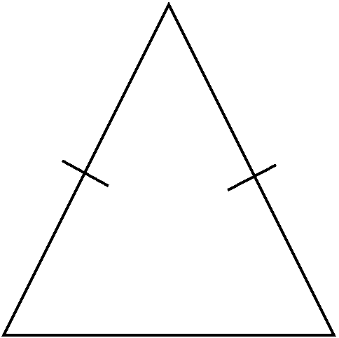
2 | Obtuse | B | 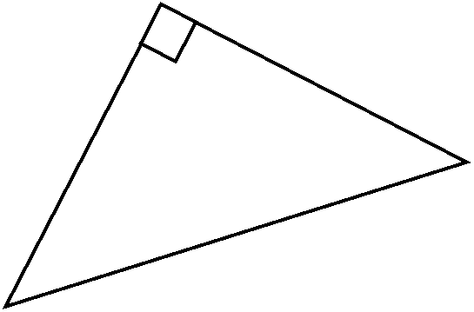
3 | Right | C | 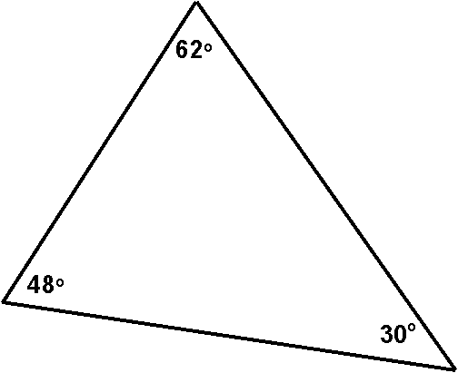
4 | Scalene | D | 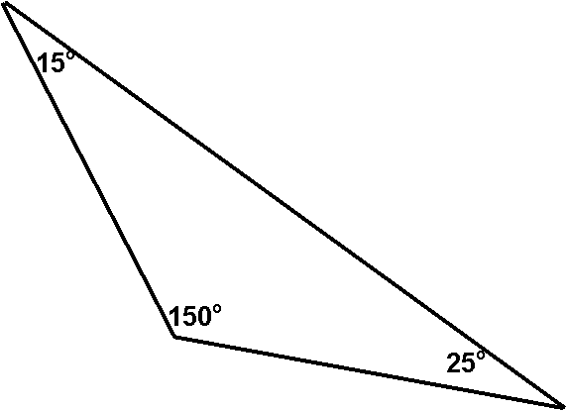
5 | Equilateral | E | 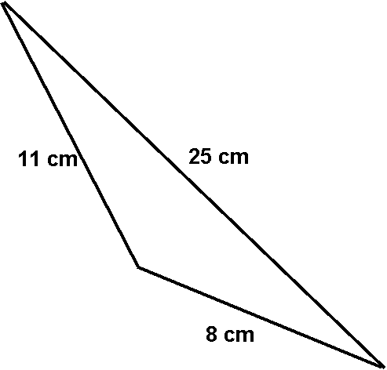
6 | Isosceles | F | 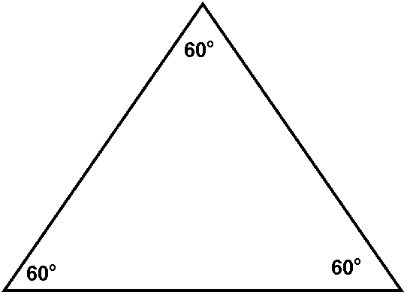
1.3.2: Growing and Shrinking Triangles

Investigation
Find the area and perimeter of the triangle.



If another triangle of the same shape has a perimeter that is double, what is the effect on the area? If another triangle of the same shape has a perimeter that is half, what is the effect on the area?

Hypothesis

If one triangle of the same shape has double the perimeter of the original triangle, the resulting

area of the triangle would be _________________________.

Complete the investigation.
Show your work and explain your reasoning. Generalize by stating the relationship between the perimeter and the area of similar triangles. State a conclusion based on your work. This conclusion may be based on your original hypothesis.
Unit 1: Day 4: What Is Similarity? |  |  |  |  | Grade 10 Applied
Minds On: 15 Min. |  |  | Math Learning Goals  - Investigate the properties of similar triangles using geoboards, e.g., corresponding angles are equal and corresponding sides are proportional. |  | Materials  - BLM 1.4.1, 1.4.2, 1.4.3, 1.4.4  - 11-pin transparent geoboards  - Geobands  - Ruler  - Protractor
Action: 45 Min.
Consolidate/
Debrief: 15 Min
Total = 75 Min.
Assessment
Opportunities
 | Minds On… | Pairs à Guided Discussion  Students complete BLM 1.4.1.  Individual à Activating Prior Knowledge  Option 1  Students complete the Before column of the Anticipation Guide (BLM 1.4.2).  Option 2  Students complete the What I Know and What I Want to Know columns  (BLM 1.4.2). |  |  | Select one of the two options on  BLM 1.4.2 to activate prior knowledge.  Provide only the number of bands needed.  Establish that one unit is the horizontal or vertical length between two pegs on the geoboard.
 | Action! | Pairs à Investigation  Learning Skills/Teamwork/Observation/Anecdotal Note: Observe pairs of students for cooperative learning, sharing of responsibilities, on-task behaviour.  Students complete questions 1–4 on BLM 1.4.3.  Guide students through question 5 to establish properties of similar triangles before completing the remaining questions. Include how to write a similarity equation for the corresponding sides of similar triangles.  For question 6, students represent each triangle on a separate geoboard to determine the corresponding angle measurements by translating, rotating, or reflecting.
 | Consolidate Debrief | Pairs à Reflecting  Students complete the After column or the What I Learned column on  BLM 1.4.2.
Application  Concept Practice |  | Home Activity or Further Classroom Consolidation  Complete worksheet 1.4.4.

1.4.1 What is Similarity?
What does it mean if we say that 2 objects are similar?
See if you can find out by using the clues below.
Hint: Use a ruler and a protractor to make measurements.
Clue #1 These 2 objects are similar | Clue #2 These 2 objects are not similar
Clue #3 These 2 objects are similar | Clue #4 These 2 objects are not similar
Clue #5 These 2 objects are similar | Clue #6 These 2 objects are not similar
Clue #7 These 2 objects are similar | Clue #8 These 2 objects are not similar

Did you get it? What do you think similarity means?

Formal Definition of Similarity:

1.4.1 What is Similarity? (continued)
In each question, decide if the objects are similar (yes or no) and then explain:
Hint: Use a ruler and a protractor to make measurements.

Similar? _________
Explain:

Similar? _________
Explain:

Similar? _________
Explain:

Similar? _________
Explain:

Similar? _________
Explain:

Similar? _________
Explain:

1.4.2: What Is Similarity?

Anticipation Guide

Before |  | Statement | After
Agree | Disagree | Statement | Agree | Disagree
 |  | In a triangle, I can calculate the length of the third side if I know the length of the other two sides.
 |  | All triangles are similar.
 |  | All squares are similar.
 |  | When I enlarge a geometric shape, the number of degrees in each angle will become larger.

K-W-L Chart

Statement | What I Know | What I Want to Know | What I Learned
Pythagorean relationship

If two triangles are similar, then..

1.4.3: What Is Similarity?

1. a) On your geoboard create a right-angled triangle with the two perpendicular sides having lengths 1 and 2 units.

b) Create two more triangles on your geoboard that are enlargements of the triangle created in a).


2. Draw the three triangles using different colours on the grid and label the vertices, as indicated:
- triangle one (label vertices ABC)
- triangle two (label vertices DEF)
- triangle three (label vertices GHJ)

3. a) Determine the lengths of the hypotenuse of each of the :
(Hint: Pythagorean Theorem)
rABC | rDEF | rGHJ

b) Indicate the length of each side of each triangle on the diagram.

1.4.3: What Is Similarity? (continued)

4. a) Place rABC, rDEF, and rGHJ on the geoboard so that one vertex of each triangle is on the same peg and two of the sides are overlapping.

b) Copy your model on the grid.

5. a) What do you notice about the corresponding angles of rABC, rDEF, and rGHJ?

b) What do you notice about the corresponding sides of rABC, rDEF, and rGHJ?

Summary

I know the following about similar triangles:

1.4.3: What Is Similarity? (continued)

6. Use the geoboards to explore whether the following triangles are similar.
a)  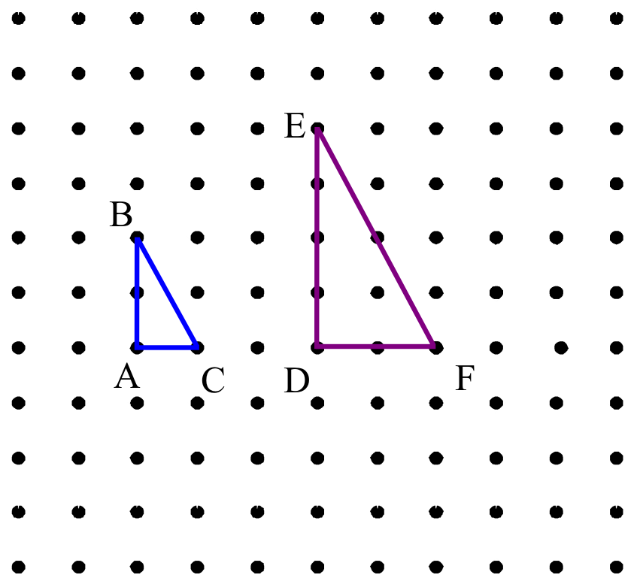 | Explain your reasoning.
b)  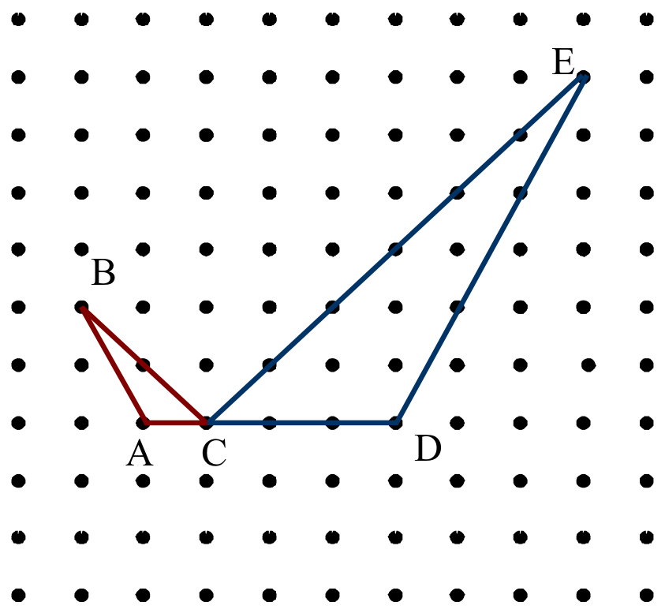 | Explain your reasoning.
c)  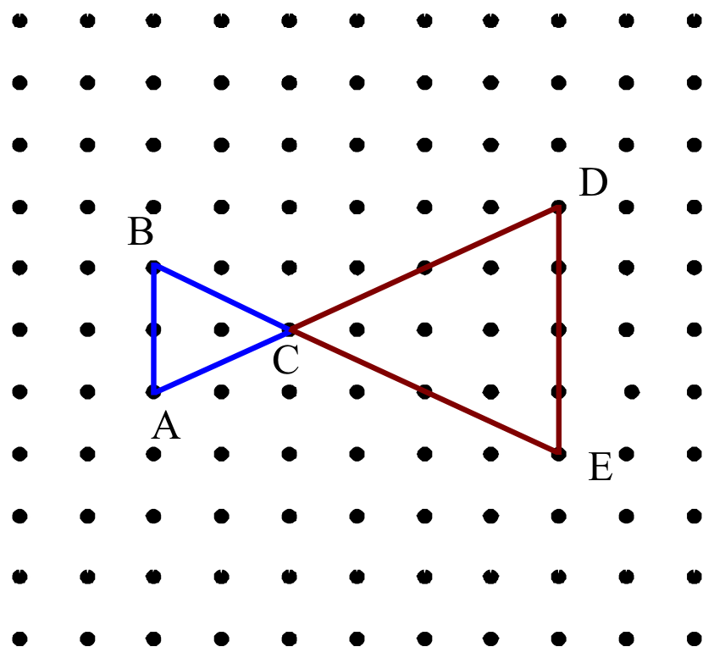 | Explain your reasoning.

1.4.4: Exploring Similarity

1. Which of the following four houses are similar? Explain why.
Label the diagrams.

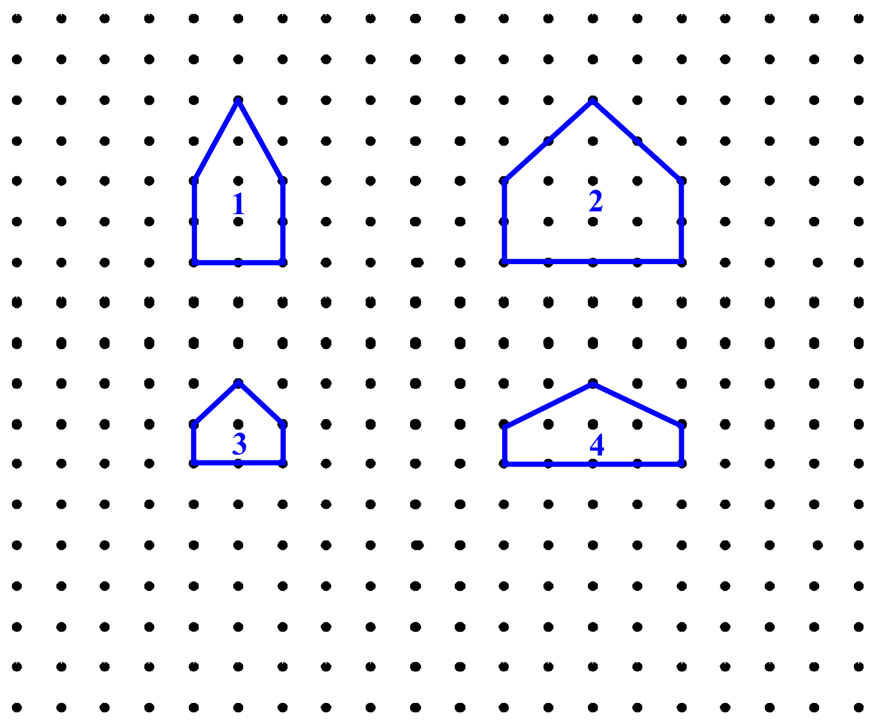

2. On the grid, draw a house that is similar to one of the figures.
Complete the following statement:
The house I drew is similar to house #______.

I know this because:

Unit 1: Day 5: Properties of Similar Triangles |  |  |  |  | Grade 10 Applied
Minds On: 10 Min. |  |  | Math Learning Goals  - Investigate the properties of similar triangles, i.e., corresponding angles are equal and corresponding sides are proportional, using concrete materials. |  | Materials  - BLM 1.5.1, 1.5.2, 1.5.3  - GSP®4 (optional)  - protractors  - rulers  - legal- and letter-sized paper  - scissors
Action: 45 Min.
Consolidate/
Debrief: 20 Min
Total = 75 Min.
Assessment
Opportunities
 | Minds On… | Small Groups → Discussion  Students complete a Frayer model for similar triangles based on their learning from the previous day’s lesson (BLM 1.5.1). Students should keep this work for reference throughout the course.  Optional: Discuss briefly the differences and similarities between similar shapes and congruent shapes. |  |  | Using grid paper or  GSP®4 facilitates this activity.  Preview the activity prior to assigning it to class.  See Mathematical Processes in LMS Library.
 | Action! | Whole Class → Instructions  Outline the key elements of the paper cutting activity.  Pairs → Exploration  Students follow the instructions in B.L.M. 1.5.2 to create similar triangles.  Each partner completes BLM 1.5.2 using a different-sized piece of paper (8× 11, 8× 14) and they compare their results.  Reasoning and Proving/Oral Question/Anecdotal Note: As students work, circulate, and ask questions so they can demonstrate they are using reasoning skills.
 | Consolidate Debrief | Whole Class → Discussion  Discuss answers from BLM 1.5.2, reinforcing that similar triangles have equal angles and sides that are proportional. Students should see this connection with the results of the exploration.  Consolidate how to determine a scale factor for the corresponding sides of similar triangles, and how to solve for missing information.
Application  Concept Practice |  | Home Activity or Further Classroom Consolidation  Find the missing information for pairs of similar triangles (BLM 1.5.3) |  |  | Provide students with several pairs of similar triangles with some information given.

1.5.1: Similar Triangles

Definition | Properties/Characteristics
Examples | Non-examples  Similar Triangles

1.5.2: Finding Similar Triangles

You and your partner will need:
- one sheet of legal size paper and one sheet of letter size paper.
- protractor
- ruler
- scissors

- Measure and label the side lengths on your piece of paper. Write a large signature across the back of your piece of paper. (You may need this later.)

- Each rectangle has two diagonals. Fold your paper along one of the diagonals. Cut the paper along the diagonal.

- What do you notice about the two triangles that you have created?

- Take one of the two congruent triangles and set it aside. Take the other one and using a ruler and protractor draw a line that is perpendicular to the hypotenuse and passes through the vertex of the right angle. Cut the paper along this line. You should now have three triangles.

Label the vertices of each triangle with appropriate letters (Largest triangle is ΔABC, Middle triangle is Δ DEF, Smallest triangle is ΔGHJ.)

Explore the relationship between the triangles by reorienting them and overlapping the three triangles so that corresponding angles are in the same place.

- Identify any triangles that you think are similar. Explain.

1.5.2: Finding Similar Triangles (continued)

- Using a ruler and protractor complete the table below to determine whether the triangles are similar.

Triangle | Hypotenuse | Shortest side | Middle side | Angles
ΔABC

Δ DEF

ΔGHJ

- Complete the following calculations.

$\frac{\text{Length}⋅\text{of}⋅\text{hypotenuse}⋅\text{of}⋅Δ\text{DEF}}{\text{Length}⋅\text{of}⋅\text{hypotenuse}⋅\text{of}⋅Δ\text{ABC}}=$ $\frac{\text{Length}⋅\text{of}⋅\text{hypotenuse}⋅\text{of}⋅Δ\text{DEF}}{\text{Length}⋅\text{of}⋅\text{hypotenuse}⋅\text{of}⋅Δ\text{GHK}}=$

$\frac{\text{Length}⋅\text{of}⋅\text{shortest}⋅\text{side}⋅\text{of}⋅Δ\text{DEF}}{\text{Length}⋅\text{of}⋅\text{shortest}⋅\text{side}⋅\text{of}⋅Δ\text{ABC}}=$ $\frac{\text{Length}⋅\text{of}⋅\text{shortest}⋅\text{side}⋅\text{of}⋅Δ\text{DEF}}{\text{Length}⋅\text{of}⋅\text{shortest}⋅\text{side}⋅\text{of}⋅Δ\text{GHK}}=$

$\frac{\text{Length}⋅\text{of}⋅\text{middle}⋅\text{side}⋅\text{of}⋅Δ\text{DEF}}{\text{Length}⋅\text{of}⋅\text{middle}⋅\text{side}⋅\text{of}⋅Δ\text{ABC}}=$ $\frac{\text{Length}⋅\text{of}⋅\text{middle}⋅\text{side}⋅\text{of}⋅Δ\text{DEF}}{\text{Length}⋅\text{of}⋅\text{middle}⋅\text{side}⋅\text{of}⋅Δ\text{GHK}}=$

- What do you notice about the ratios you have calculated in each column? State each ratio. This ratio is called a scale factor.

1.5.2: Finding Similar Triangles (continued)

- What conclusions about the triangles can you draw based on the ratios calculated in question 7? Are they similar or not? Explain.

- If you were given a triangle with side lengths specified and a scale factor how could you use this information to determine the side lengths of the similar triangle that would be created?

- Use your method above to solve the following triangles.

10cm 5cm
8 cm x

- Try to recreate your original rectangle.

1.5.2: Similar Triangles Practice

- Calculate the missing information for the following pairs of similar triangles.

a)

16 8

b
3
11
a

b)

5 5.5 15 c

d

18

Unit 1: Day 6: Let’s Do Proportions |  |  |  |  | Grade 10 Applied
Minds On: 15 Min. |  |  | Math Learning Goals  - Identify and create proportional ratios.  - Solve proportions to obtain missing information in similar triangles. |  | Materials  - Chart Paper  - Markers  - BLM 1.6.1, 1.6.2, 1.6.3  - Picture of teacher  - Tape measure
Action: 50 Min.
Consolidate/
Debrief: 10 Min
Total = 75 Min.
Assessment
Opportunities
 | Minds On… | Whole Class → Discussion  Post a picture of the teacher (ensuring that a measurement can be taken from head to toe). Have students measure the height of the teacher in the picture and in real life and discuss the scale factor.  Measure other students and discuss how to determine the student’s height in that same picture. |  |  | Could use a picture of any person/object available in your room.  Using CAS technology facilitates this activity.
 | Action! | Groups of 3 → Chart Paper  Using BLM 1.6.1 assign each group column a), b) or c) for all four questions.  Groups complete their section of the page on the chart paper for sharing.  Reasoning and Proving/Oral Question/Anecdotal Note: As students work, circulate, and ask questions so they can demonstrate they are using reasoning skills.  Ask one group from each column to present their solutions. Discuss methods used for solving the proportions.  Whole Class → Guided Discussion  Guide students in solving proportions related to missing values in similar triangles (BLM 1.6.2).
 | Consolidate Debrief | Whole Class → Summary  Complete BLM 1.6.P question 1, clarifying each aspect of the question.
Concept Practice |  | Home Activity or Further Classroom Consolidation  Complete worksheet 1.6.3.  Learning Skills/WorkHabits/Observation/Checklist: Check homework completion at beginning of next lesson.

1.6.1: Let’s Do Proportions
1. State whether the ratios are proportional. Give reasons to support your answers.

a) $\frac{\text{11}}{\text{12}}$, $\frac{\text{18}}{\text{27}}$ | b) $\frac{6}{\text{102}}$, $\frac{1}{\text{17}}$ | c) $\frac{\text{11}}{8}$, $\frac{\text{22}}{\text{16}}$

2. Solve each proportion.

a) $\frac{2}{\text{18}}=\frac{b}{6}$ | b) $\frac{a}{7}=\frac{\text{18}}{\text{42}}$ | c) $\frac{2}{\text{14}}=\frac{1}{k}$

3. Solve each proportion.

a) $\frac{u}{\text{12}}=\frac{\text{25}}{\text{10}}$ | b) $\frac{5}{d}=\frac{4}{6}$ | c) $\frac{6}{8}=\frac{r}{9}$

4. Create a proportion from each set of numbers. Only use four (4) numbers from each set of numbers.
a) 21, 7, 18, 6, 14 | b) 16, 2, 1, 21, 8 | c) 10, 15, 20, 25, 30

1.6.2: Solving Those Proportions

- Solve the following.
a) $\frac{3}{5}=\frac{x}{\text{20}}$ | b) $\frac{x}{3}=\frac{5}{6}$ | c) $1\text{.}5:3=y:\text{10}$ | d) $h:\text{25}=4:\text{10}$

2. These are two similar triangles.

(a) Which proportion could be used to solve for x?
9
15
24
x
12
32

(b) Now, solve that proportion.

3. AB is parallel to DE. Solve for h and k. (Hint: Redraw the triangles so that the corresponding angles are in the same position.)

2
h
3
k
10
12
A
B
C
D
E
1.6.3: Practice

1. Flagpole: The flagpole casts a shadow 14.5 m long at the same time that a person 1.8m tall casts a shadow 2.5 m long. Find the height of the flagpole. (Draw a diagram.)

2. CN Tower: The CN Tower casts a shadow 845.8m long. A 1.83m tall person standing near the tower casts a shadow 3.05m long. How tall is the CN Tower?

3. Communication: If two triangles are similar, explain, in your own words, what that means?

4. A triangle has sides whose lengths are 5, 12, and 13. A similar triangle could have sides with lengths of ________? Give side lengths of two (2) different similar triangles.

Unit 1: Day 7: How Far? How High? |  |  |  |  | Grade 10 Applied
Minds On: 10 Min. |  |  | Math Learning Goals  - Solve problems involving similar triangles using primary source measurement data. |  | Materials  - BLM 1.7.1, 1.7.2, 1.7.3, 1.7.4  - measuring tapes  - metre sticks  - mirrors
Action: 50 Min.
Consolidate/
Debrief: 15 Min
Total = 75 Min.
Assessment
Opportunities
 | Minds On… | Whole Classà Investigation  Ask: Did you know that your arm is about ten times longer than the distance between your eyes? Verify by measuring.  Use the classroom clock or a parked car you can see through the classroom window as an example of the object whose distance you want to determine.  Explain the activities How Far? (BLM 1.7.1) and How High? (BLM 1.7.2, 1.7.3, 1.7.4). |  |  | Verifying the ratio of arm length to distance between eyes can lead to a discussion on accuracy as well as specifying the endpoints used to measure the distance between eyes.  Gymnasiums, atriums, courtyards, multi-storied rooms, etc. are excellent areas to complete this activity.  Activity 2 may need to be omitted based on outdoor weather conditions.
 | Action! | Groups of 4 à Activity  Students complete the activities How Far? (BLM 1.7.1) and How High?  (BLM 1.7.2, 1.7.3, 1.7.4).  Each student writes a complete solution.  Curriculum Expectation/Demonstration/Checklist: Assess how students apply the properties of similar triangles to solve problems
 | Consolidate Debrief | Whole Class à Report/Discussion  Each group reports on its findings. Use height calculations of the same object from different groups to further discuss accuracy and the reasons why there may be different heights calculated for the same object.  Learning Skills/Teamwork/Observation/Checklist: Assess how students work together to provide and present solutions.  Students complete and submit an “Exit Card” (BLM 1.7.5)
Application |  | Home Activity or Further Classroom Consolidation  Find the height or length of an inaccessible object, using similar triangles,  e.g., the height of a tree or streetlight. Write a short report which includes a labelled diagram and a mathematical solution.  Learning Skills/WorkHabits/Observation/Checklist: Check homework completion at beginning of next lesson

1.7.1: How Far?

ACTIVITY 1

Your arm is about ten times longer than the distance between your eyes. Verify.
Arm length: ___________ cm
Distance between eyes: ___________ cm
Ratio of arm length to distance between eyes: _________ cm

1. Select an object from which you want to determine the distance. _____________ (object)

2. Estimate the width of the object. ______________ cm

3. Hold one arm straight out in front of you, elbow straight, thumb pointing up. Close one eye, and align one side of your thumb with a particular spot on the front of the object. Without moving your head or arm, sight with the other eye. Your thumb will appear to jump sideways.
a) Approximate the number of widths of the object your thumb appeared to move. _______
b) What is the distance the image moved? _________ cm
4.
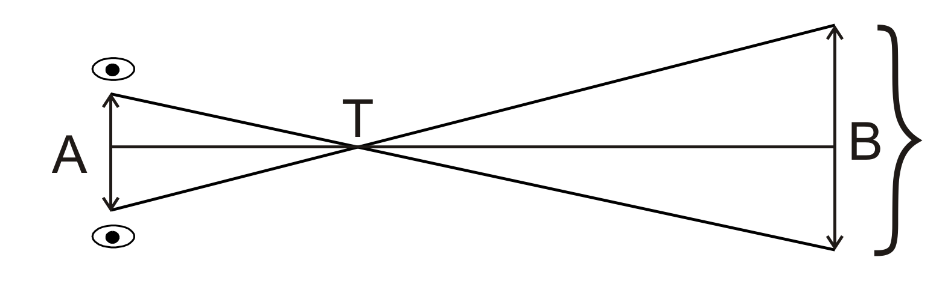 | Distance the image moved

In the diagram:
T is the position of your thumb.
AT represents the length of your arm.
TB represents the distance from your thumb to the object.

a) Indicate all known measurements on the diagram. Include units.

b) Identify which triangles are similar. Label the triangle vertices.
Write the proportion needed to find the distance the object is from you.

c) Determine the distance the object is from you, using two different methods.
1.7.2: How High? – Part 1

ACTIVITY 2

1. Select an object whose base is at right angles to the ground and whose height you cannot measure. ____________________(object)

2. Measure the length of the shadow of the object. (Indicate units.) _____________

3. Hold a metre/yard stick at right angles to the ground, and measure the length of its shadow. (Use the same units as in question 2.) _________________

4. Draw similar triangles representing this situation in the space below. Label the diagram and indicate all known measurements with units.

5. Write the proportion needed to find the desired height.

6. Calculate the height of the object. Show your work.

1.7.3: How High? – Part 2

ACTIVITY 3

1. Select an object whose height you cannot measure. ____________________ (object)

2. Lay a small mirror horizontally on the ground exactly 1 metre in front of the object.

3. Slowly walk backwards until you can just see the top of the object in the mirror.
Measure your distance from the mirror. ________________

4. Measure the distance from the ground to your eye level. _____________

5. Draw similar triangles representing this situation in the space below. Label the diagram and indicate all known measurements with units.

6. Write the proportion needed to find the desired height.

7. Calculate the height of the object. Show your work.
1.7.4: How High? – Part 3

ACTIVITY 4

1. Select an object whose height you cannot measure. ______________________________

2. Person 1: Walk at least 20 large steps away from the object.
Place your eye as close to the ground as possible and close your top eye. Your job will be to line up the top of the metre stick with the top of the object.

3. Person 2: Place the metre stick between Person 1 and the object. The metre stick must be kept at a 90˚ angle with the ground. Slowly move the metre stick towards or away from the object on the instructions of Person 1. Hold still when Person 1 has lined up the objects.

4. Persons 3 and 4: Measure the distance from Person 1 to the metre stick. ____________ Then measure the distance from Person 1 to the object. _____________

5. Draw similar triangles representing this situation in the space below. Label the diagram and indicate all known measurements with units.

6. Write the proportion needed to find the desired height.

7. Calculate the height of the object. Show your work.

1.7.5: Exit Cards - Teacher


Write one thing you learned in today’s activity.

Write one question you have about today’s activity

Write one thing you learned in today’s activity.

Write one question you have about today’s activity

Unit 1: Day 8: Proportions Potpourri |  |  |  |  | Grade 10 Applied
Minds On: 10 Min. |  |  | Math Learning Goals  - Consolidate concept understanding and procedural fluency for proportions and similar triangles.  - Solve problems involving ratios, proportions and similar triangles in a variety of contexts. |  | Materials  - BLM 1.8.1, 1.8.2, 1.8.3
Action: 50 Min. |  |  |  |  | Materials  - BLM 1.8.1, 1.8.2, 1.8.3
Consolidate/  Debrief: 15 Min |  |  |  |  | Materials  - BLM 1.8.1, 1.8.2, 1.8.3
Total = 75 Min. |  |  |  |  | Materials  - BLM 1.8.1, 1.8.2, 1.8.3
Assessment
Opportunities
 | Minds On… | Whole Class → Discussion  Using BLM 1.8.1, discuss strategies to plan and then solve this problem. Remind them this is another relevant use of solving proportions to determine missing measurements. |  |  | Teacher solution is on the first version of BLM 1.8.1.  Make as many copies of  BLM 1.8.2 as there are groups. Cut out the questions and create piles of each question number.  Students are allowed to use their notes and reference sheets for this activity.
 | Action! | Groups of 4 → Review Relay  Form heterogeneous groups. Each group completes the first question  (BLM 1.8.2). A group member verifies with the teacher that the answer is correct before receiving the next question; incorrect solutions must be corrected by the group.  Learning Skills/Teamwork/Observation/Checklist: Observe how well students work as a productive team to complete the problems.
 | Consolidate Debrief | Individual → Practice  Students complete BLM 1.8.3 independently to confirm personal understanding. Students present solutions.
Application  Concept Practice  Reflection |  | Home Activity or Further Classroom Consolidation  Prepare for the unit assessment by completing practice questions, creating reference sheets, and organizing your notes. |  |  | Reference sheets could be an accommodation for identified exceptional students.

1.8.1: Eye, eye, eye!! - Teacher

Hurricanes are violent storms, which form over the warm waters of the oceans. Each year hurricanes cause millions dollars of damage when they hit coastal areas. Hurricanes can produce winds with speeds up to 241 or more kilometres per hour. The centre of a hurricane is called the EYE. Inside the eye of a hurricane there is almost NO WIND. The air is perfectly calm and just outside the eye are the most violent winds of the storm. How far across is the eye of this hurricane (in km)? Photo taken with a 90mm camera lens on a Linhof camera at an altitude of 267 km. Draw a diagram to help.

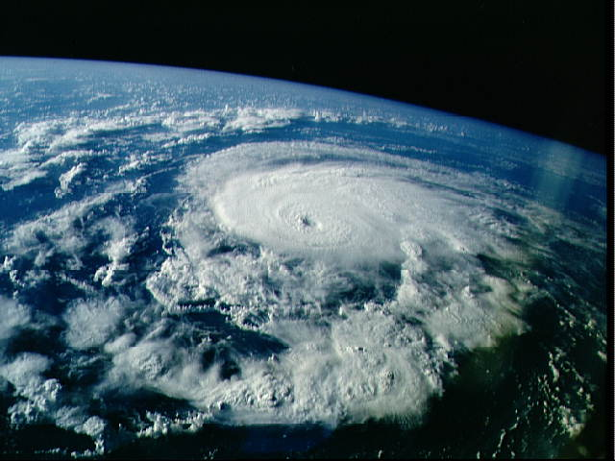
Eye

Solution: (to provide assistance in the set-up of this problem)
Excellent opportunity to review metric conversions.

Width of eye = altitude
Width of eye in picture width of lens

x = 267 000 000 (all units in mm)
13 90

x = 38 566 667 mm

= 38.6 km

1.8.1: Eye, eye, eye!!

Hurricanes are violent storms, which form over the warm waters of the oceans. Each year hurricanes cause millions dollars of damage when they hit coastal areas. Hurricanes can produce winds with speeds up to 241 or more kilometres per hour. The centre of a hurricane is called the EYE. Inside the eye of a hurricane there is almost NO WIND. The air is perfectly calm and just outside the eye are the most violent winds of the storm. How far across is the eye of this hurricane (in km)? Photo taken with a 90mm camera lens on a Linhof camera at an altitude of 267 km. Draw a diagram to help.

Eye

1.8.2: Review Relay - Teacher

1. Only the shadow knows…and you should too!  Problem: A 12-m tree casts a 16-m shadow. How many feet tall is a nearby tree that casts a 20-m shadow at the same time? | 2. Map reading  Problem: On a scale drawing of a school playground a triangular area has side lengths of 8 cm, 15 cm and 17 cm. If the triangular area on the playground has a perimeter of 120 m, what is the length of its longest side?
3. VCR: Do you always get 6 hours of recording on a 6 hour tape?  Problem: Suppose the setting SP(standard play) on a VCR allow 2 hours of recording on an ordinary 120-minute tape. Changing the setting to EP(extended play) allows 6 hours of recording. After taping a 30 minute show on SP, the VCR is reset to EP. How many more 30-minute shows can be recorded on this tape? | 4. Sailing away  Problem: Trevor’s sailboat has two sails that are similar triangles. The largest sail has side lengths of 10 m, 24 m and 26 m. If the smallest side of the smaller sail has a side length of 6 m, what is the perimeter of the smaller sail?
1.8.2: Review Relay – Teacher (Continued)
5. How tall?  Problem: An image of a building in a photograph is 6 centimeters wide and 11 centimeters tall. If the image is similar to the actual building and the actual building is 174 meters wide, how tall is the actual building, in meters? | 6. Material anyone?  Problem: The lengths of the sides of two  similar rectangular billboards are in the  ratio 5:4. If 250 square metres of material is needed to cover the larger billboard, how much material, in square metres, is needed to cover the smaller billboard?
7. Camping  Problem: The Rivera family bought a new tent for camping. Their old tent had equal sides of 10 m and a floor width of 15 m, as shown in the accompanying diagram.  10 m  10 m  15 m  Old Tent  If the new tent is similar in shape to the old tent and has equal sides of 16 m, how wide is the floor of the new tent? | 8. Across the river.  Problem: A surveyor has been given the job of finding the width of a river. She cannot measure the distance across the water, but she is able to get some measurements on land as shown on the diagram below. Based on her measurements, what is the width of the river?  Land  45 m  30 m  x  9 m  River  Land

1.8.3: Practice

1. A tower casts a shadow that is 750 m long. At the same time, a metre stick casts a shadow 1.4 m long. Label the diagram. Find the height of the tower.

2. Sam places a mirror on the ground, 5 m from the base of a tree. He then walks backwards until he can see the top of the tree in the mirror. He is now standing 0.75 m from the mirror. Sam’s eye level is 1.75 m high. Label the diagram. Find the height of the tree.

